***An invitation from Vancouver Island University -  Experience VIU***

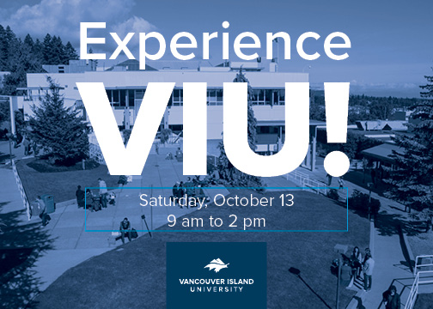On Saturday, October 13th from 9-2, Vancouver Island University is hosting Experience VIU at our Nanaimo campus.

***Why should students and their parents attend?***

This is their chance to learn all about VIU’s 120+ programs and the many services and supports available to students. Learn what it’s like to be a student here, explore our beautiful, ocean-view campus on a tour, take in a sample class or lab, and find out how you can prepare for a great career with post-secondary studies.

***Who should attend?***

Anyone interested in post-secondary studies should attend – from high school students and their parents to those people who’ve been out of school awhile and are ready to explore their options. In high school, in a job but thinking about university, or parent to a high schooler, this event is for you!

***What can I do?***

You can see what student life is like on our 92-acre Nanaimo campus, take in a sample class led by a VIU professor or a senior level student, or meet with a VIU Recruitment Officer to get your questions answered. See more below for all we have planned. It’s all very casual and it will be FUN! (Join us for lunch from 12-1.)

***Is it free?***

Yes it is! We are asking our guests to register so we can ensure we have the resources and lunch for everyone, however registration is not mandatory. All welcome! [Register for "Experience VIU"](https://www.eventbrite.ca/e/experience-viu-tickets-50134967036)

**Event Schedule**

You can take in the following sessions, running every half hour. Check us out on the [VIU Nanaimo Campus map](https://www.google.com/maps/place/Vancouver+Island+University/@49.1577569,-123.9675134,17z/data=!4m8!1m2!2m1!1sVancouver+Island+University!3m4!1s0x5488a3ed204a06ef:0x62f26560f569d288!8m2!3d49.157362!4d-123.9618899) or pick up a printed map at the Information Booth at the Welcome Centre in Bldg. to guide your visit.

* Take a Campus Tour (Building 300, Welcome Centre)
* Meet a VIU Recruitment Officer (Building 300, third floor, Royal Arbutus Room)
* Learn About Financial Aid and Awards (Location TBD)
* Explore Employment Outcomes and Labour Market Information (Location TBD)
* What’s Involved in Applying to VIU – with Registration (Building 200, Main Lobby)
* Learn About International Student Services (Building 255)

Join us for a free lunch at 12 noon in our Upper Cafeteria (Building 300)

The whole day will feature sample lectures by our faculty. For a complete listing and schedule of the lectures visit viu.ca/experience. Most lectures will be added as the event nears.

If you have any questions about this event, please feel free to contact us at [viuconnect@viu.ca](mailto:viuconnect@viu.ca)

Thanks,

VIU Recruitment Team

|  |  |
| --- | --- |
| cid:image006.jpg@01D44F3B.BDA94980 | **Marketing, Analytics, Recruitment & Communications Vancouver Island University** 250.740.6672 Apply: [viu.ca/apply](https://programs.viu.ca/apply) |